Stock Count
Go to:
Inventory>>Inventory Track>> Count Stock
The Stock Count uses the Stock Count Schedule and updates the Stock Count Entry in GP.

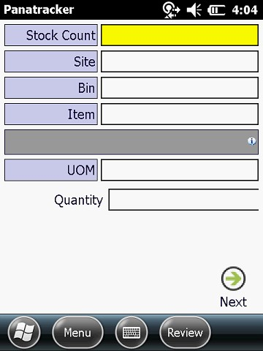
Select the Stock Count from the list.
If there is only one Site as part of the Stock Count Schedule setup, it will automatically default; otherwise, select the site being counted.
If using multiple bin tracking in GP, select the Bin that is being counted. Note: Once the bin is counted complete, use the → Next icon on the screen to reset to the Site field OR use the Bksp or Esc key to navigate back to the bin field from the Item field. Scan the items and enter the quantity for the count.
For lot tracked inventory: Lot records will be consolidated for the Site/Bin/Item for a single count record. The count will be spread across the lines on the Stock Count Entry for the lot. All listed lots must be verified before the item will be marked as counted complete.
For serial tracked inventory: Use the Skip Count to scan serial numbers. Serial numbers must be scanned.

The look up list will identify the current count on each item. A green checkmark indicates count is complete on the item. Any items that remain without a verified count will be at the top of the list.
The count status will be available to view on the Item look up, the Bin look up and the Site lookup.
Note: All items must be verified in order to process the count in GP.
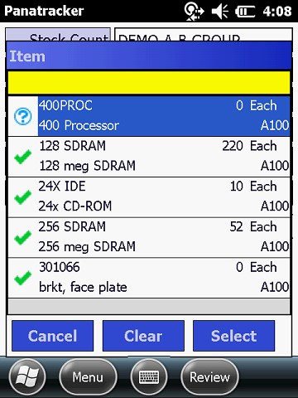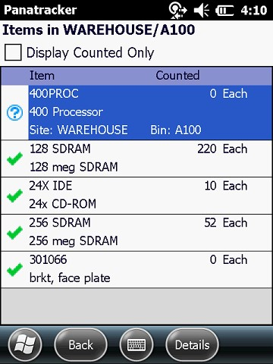

The review screen will also access the items based on the
fields populated. (By Site or by Site/Bin.) Review DOES NOT SHOW ITEMS THAT WHERE NOT IN THE BIN PRIOR TO STOCKTAKE.

Tap on the item in the list and then [Details] to review serial
or lot count status.

If the same item is scanned for the site/bin with a current count, a prompt will be displayed to add to the current count.
Always select NO and replace count with the full count of the item for that bin.

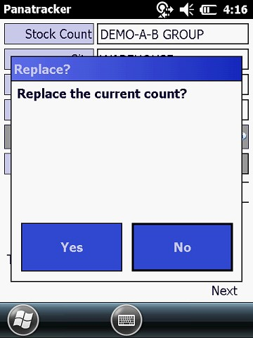
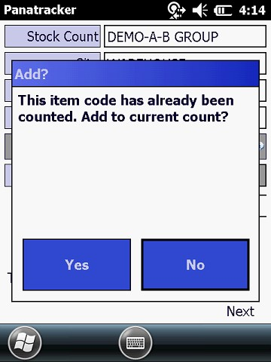
To replace an existing count, tap the [No]. The option to replace the count will be displayed. Tap [Yes] to confirm.
If there are items on the list without a count and that is not physically in the location being counted, select the item and enter a count of ‘0’ to confirm and mark as verified. This will complete the variance calculation should there be a captured quantity in GP for that item on the Stock Count Entry.

Once the counts are completed --- confirm site, bin and items all have a checkmark. Report that the count is complete for the review and processing of the Stock Count Entry in GP.
Recounting
On recount when you get the message “This item code has already been counted. Add to current count? Select YES
Then select YES on the “Replace the current count?” message.
If the item was a serial tracked item and you need to recount it will say the serial is already been counted. If count was correct then select okay and move on. If you accidentally counted a serial tracked item in the wrong bin then select the review button, find the item and drill into the count, select clear to remove that serial from the count.

